How to configure R with SAP PA Expert Analytics

There are 2 ways of configuring R for SAP Expert Analytics:

1. 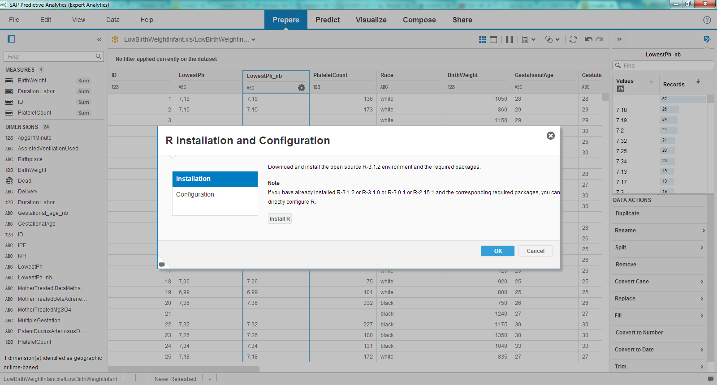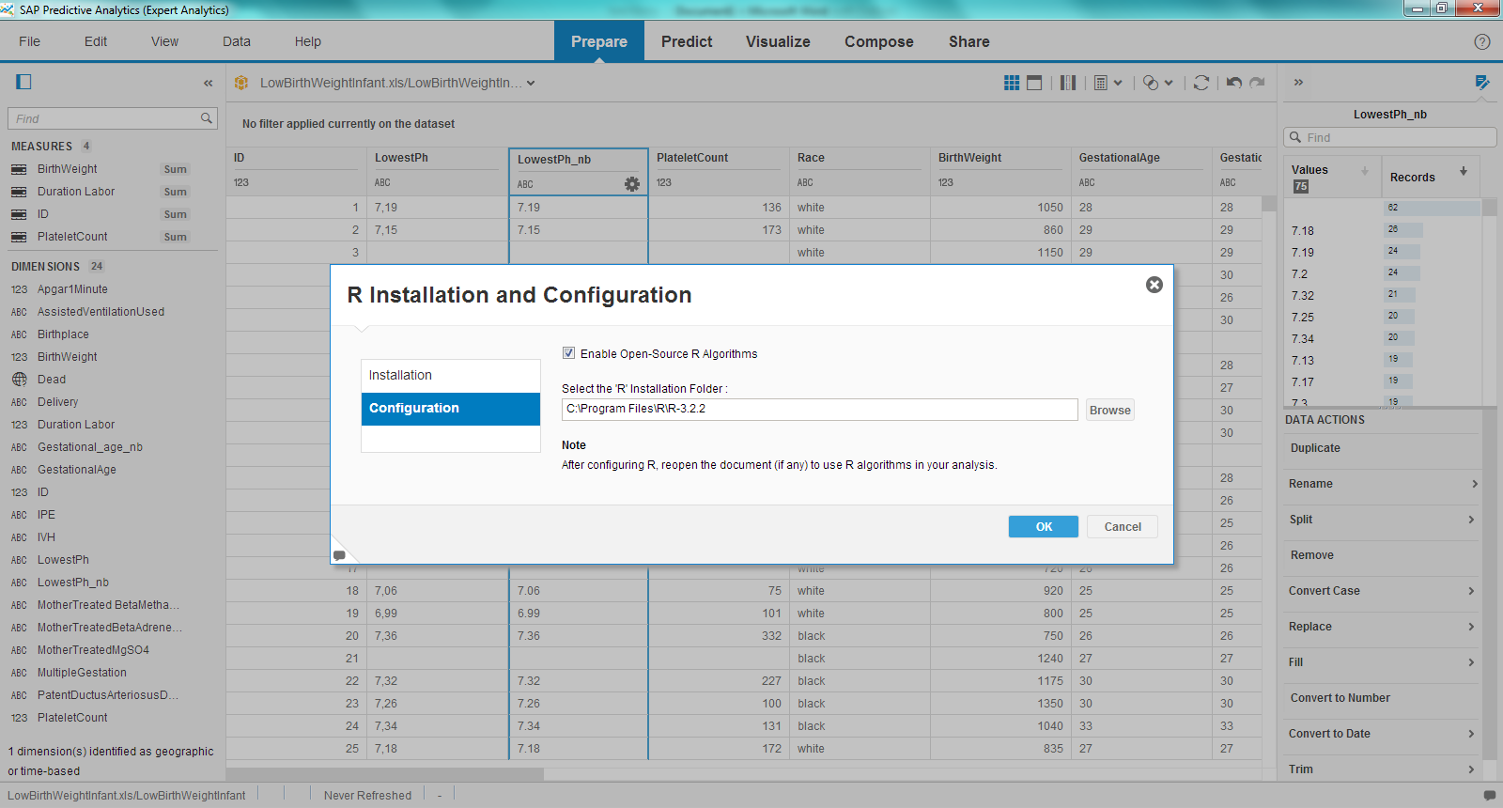From the interface 2. Outside of PA

Sometimes, doing the installation from the PA interface can take longer than normal.

That is why we will explain step-by-step how easy it can be to install and configure R from outside of the interface.

1. Download R

A simple google search will give you the possibility to download the latest version of R:

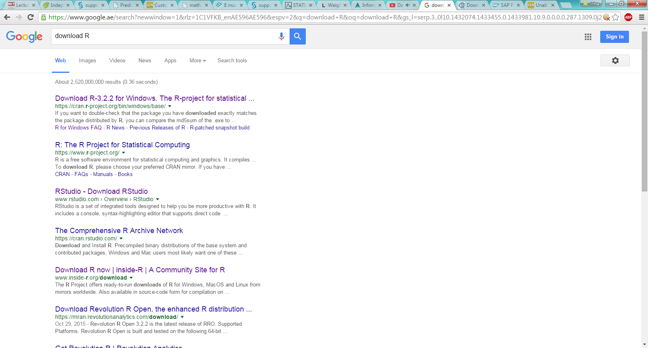

1. Install R

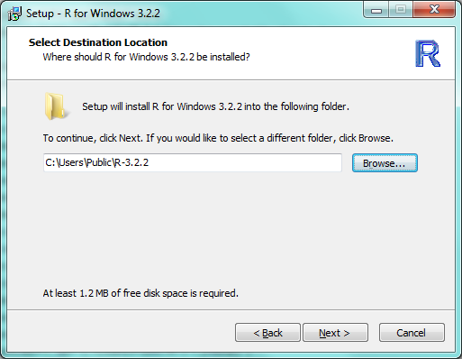After running the installer, make sure to set the following path for the installation:

“ C:\Users\Public\R-3.2.2 “

1. Install the mandatory R packages

Open R and copy-paste the following code in the console:

install.packages("rJava", dependencies=T, lib="C:/Users/Public/R-3.2.2/library")

install.packages("RODBC", dependencies=T, lib="C:/Users/Public/R-3.2.2/library")

install.packages("RJDBC", dependencies=T, lib="C:/Users/Public/R-3.2.2/library")

install.packages("DBI", dependencies=T, lib="C:/Users/Public/R-3.2.2/library")

install.packages("monmlp", dependencies=T, lib="C:/Users/Public/R-3.2.2/library")

install.packages("AMORE", dependencies=T, lib="C:/Users/Public/R-3.2.2/library")

install.packages("pmml", dependencies=T, lib="C:/Users/Public/R-3.2.2/library")

install.packages("XML", dependencies=T, lib="C:/Users/Public/R-3.2.2/library")

install.packages("arules", dependencies=T, lib="C:/Users/Public/R-3.2.2/library")

install.packages("caret", dependencies=T, lib="C:/Users/Public/R-3.2.2/library")

install.packages("reshape", dependencies=T, lib="C:/Users/Public/R-3.2.2/library")

install.packages("plyr", dependencies=T, lib="C:/Users/Public/R-3.2.2/library")

install.packages("foreach", dependencies=T, lib="C:/Users/Public/R-3.2.2/library")

1. Open SAP PA Expert ->File->Install and configure R->Configuration, and point to the installation folder:

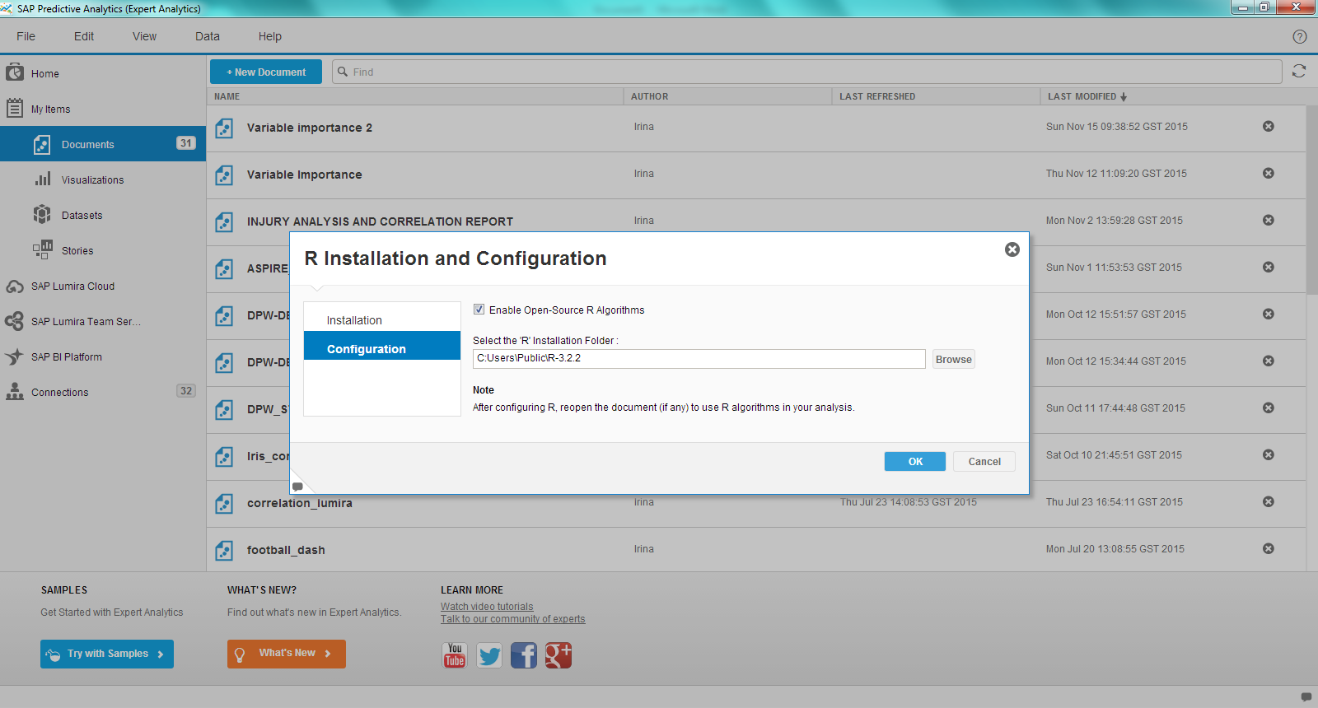

Done!